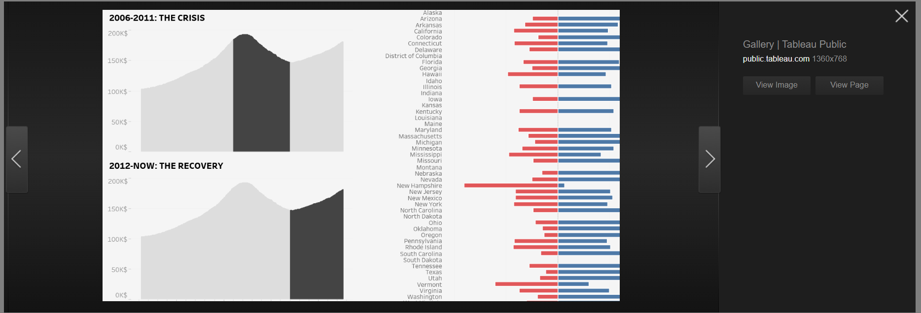

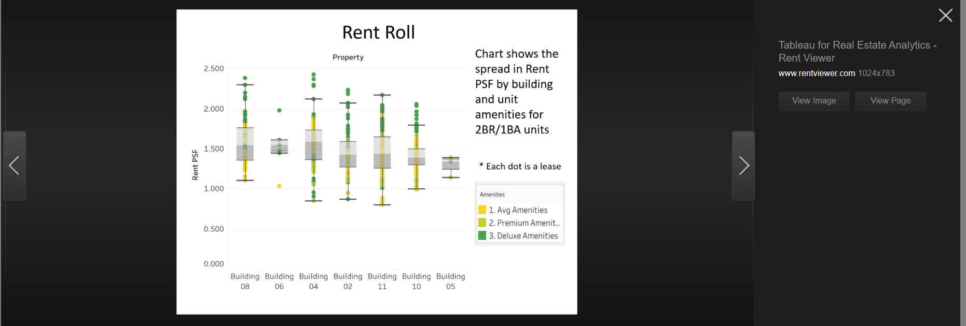

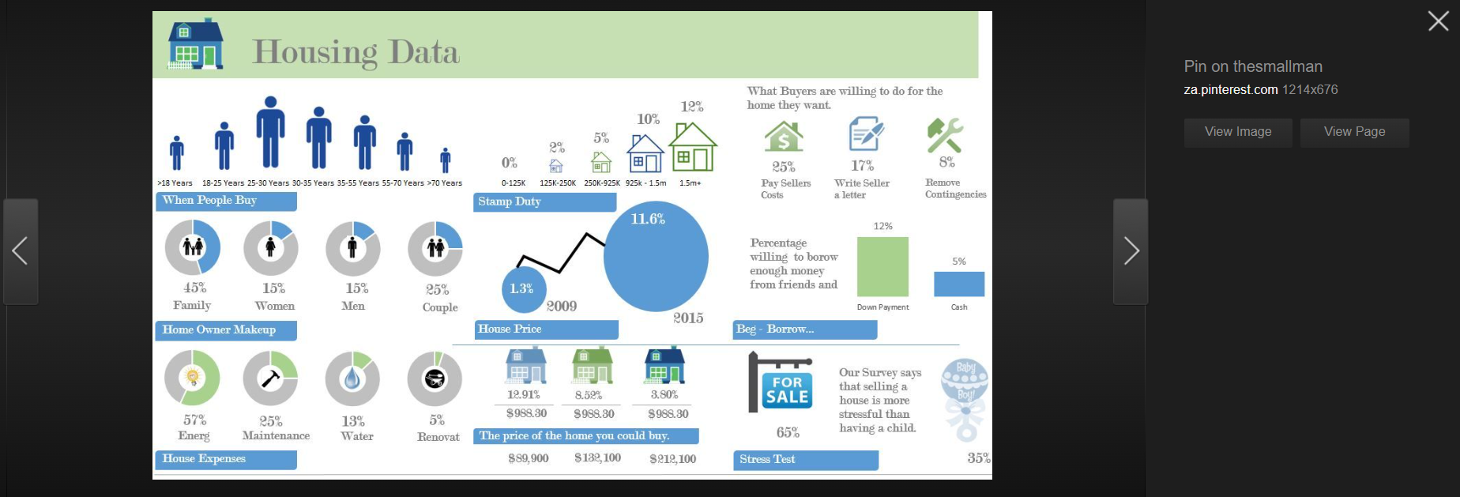

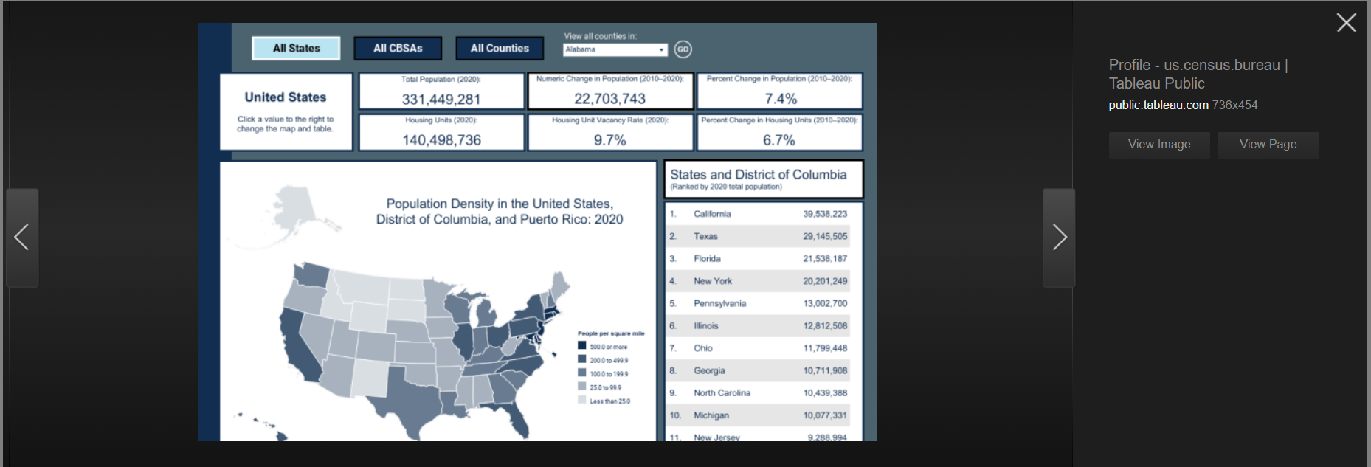

<https://public.tableau.com/app/profile/us.census.bureau/viz/2020CensusPopulationandHousingMap/AllStates>

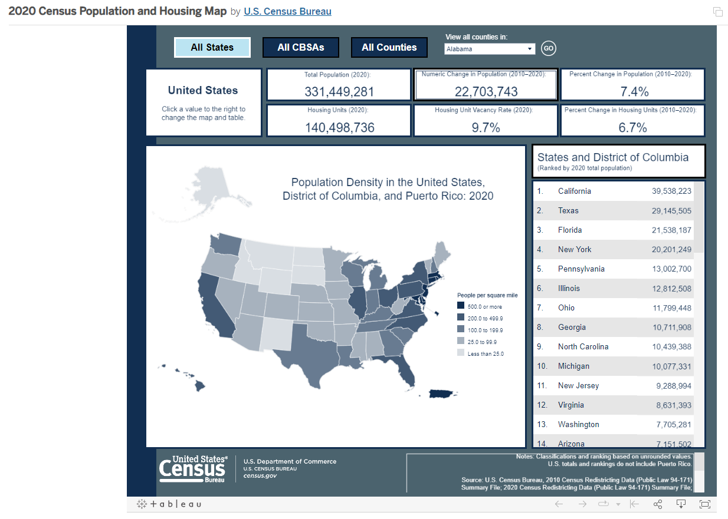

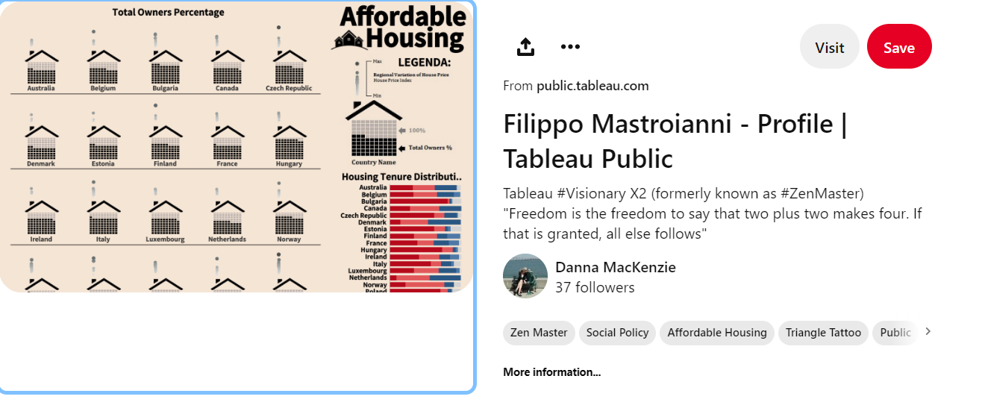

<https://pin.it/5Zb6ez5>

<https://public.tableau.com/app/profile/filippo.mastroianni/viz/AffordableHousing_2/Dashboard1>

**Must see**

INCOME AND HOUSING AFFORDABILITY DASHBOARD

<https://metrosight.com/income-housing-data-california>

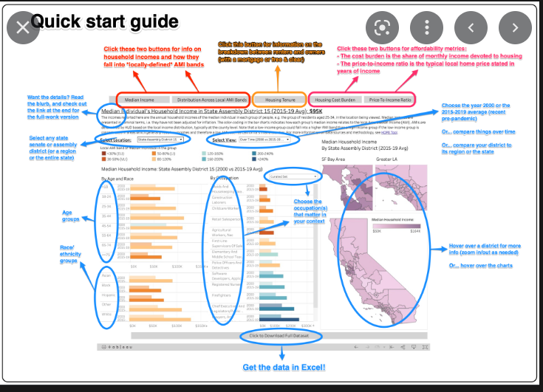

<https://labs.centerforgov.org/projects/affordability/>

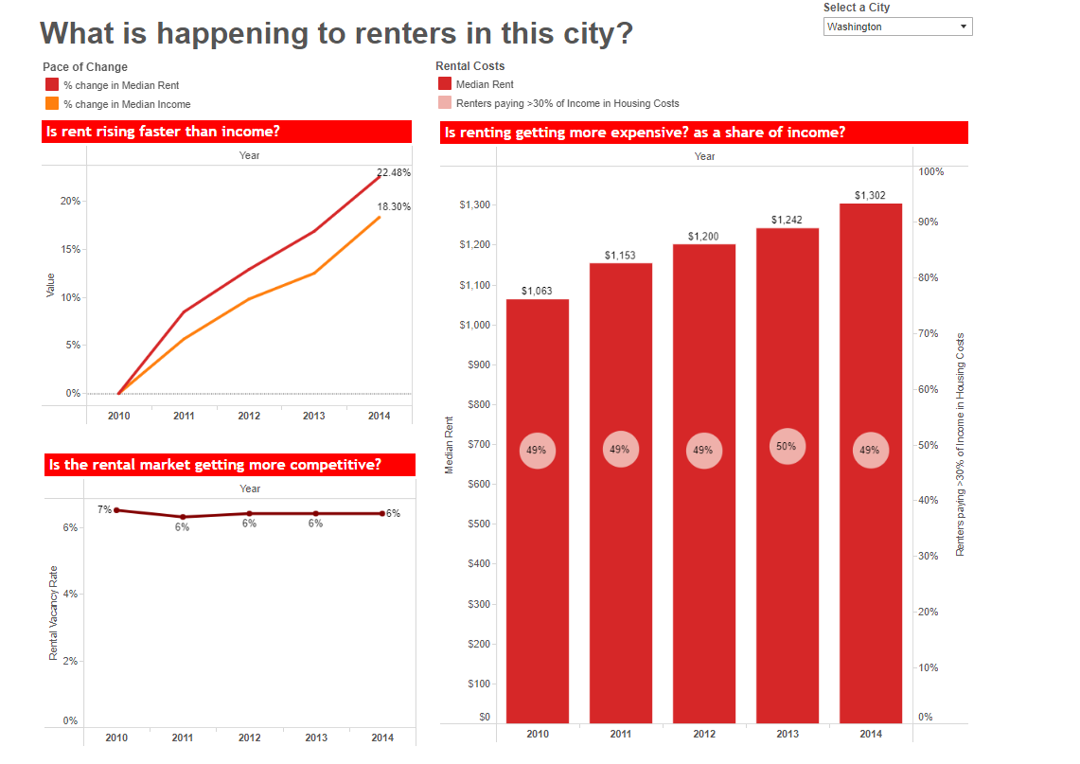

<https://www.philadelphiafed.org/-/media/frbp/assets/community-development/data-viz/housing-data-dashboard/rentalhousing-infographic.pdf?la=en&hash=542BBCE2AEB0EF84C16A0F44DBB368A0>



<https://studentwork.prattsi.org/infovis/visualization/a-brief-history-of-affordable-housing-in-new-jersey/>

